Combining Ability and Genetic Parameters of Maize
Based on S₄ Diallel-Derived Progenies

Anggada Bima Satya Wibowo¹, Darmawan Saptadi², and Budi Waluyo^{2♥}
¹Department of Agronomy, Faculty of Agriculture and Forestry Bio-Industry, Universitas Brawijaya, Malang, Indonesia
²Department of Agriculture Science, Faculty of Agriculture and Forestry Bio-Industry, Universitas Brawijaya, Malang, Indonesia
♥Corresponding author email: budiwaluyo@ub.ac.id
Article history: submitted: May 25, 2026; accepted: July 29, 2026; available online: August 10, 2026
Abstract. Maize is an important crop with strategic roles. The development of superior maize varieties requires genetically diverse parental lines with high combining ability. Advanced selfing generations, such as S4, provide increased homozygosity, allowing more reliable estimation of combining ability and genetic parameters for parental selection. This study aimed to evaluate general combining ability (GCA), specific combining ability (SCA), and genetic parameters using S₄ progenies derived from a half-diallel mating design. The experiment was conducted from August to November 2025 at PT. Sukses Seed Sentosa, Malang Regency, East Java, Indonesia, using a randomized complete block design with two replications and involving 36 S₄ cross combinations. The first two principal components of the GCA explained 82.36% of the total variation (PC1 = 63.26%; PC2 = 19.10%). P4 exhibited superior GCA for cob diameter and days to harvest, whereas P1 showed favorable GCA for multiple yield-related traits. SCA values showed that the first two principal components explained 84.54% of the total variation (PC1 = 74.46%; PC2 = 10.08%). P2 × P6 showed the highest SCA for multiple yield-related traits, while P2 × P4 was superior for days to silking and shelling percentage. High GCV was observed in AWC (25.26), SWC (25.62), and Y (23.79). High narrow-heritability was observed for DA (0.55), cob length (0.60), and NSPR (0.66). Most traits were predominantly controlled by additive gene action, whereas grain yield and number of seeds per cob were mainly governed by non-additive gene action.
Keywords: gene action; genetic advance; heritability; mating design; parental selection

1. Introduction
Maize (Zea mays L.) is a major food crop vital to food security in Indonesia. Maize ranks third among the principal food crops, after rice and wheat. Maize contains, among other things, carbohydrates, protein, vitamin C, vitamin E, vitamin K, vitamin B, folic acid, and phenolic compounds (Rouf Shah et al., 2016). The many benefits of maize have resulted in high demand. Maize plays a highly strategic role as a raw material for industry, animal feed, pharmaceuticals, and bioenergy (Putri et al., 2022; Supriadi et al., 2024). Maize genotypes with high yield potential and quality are required to develop hybrid maize varieties. To achieve this goal, breeders need populations with high genetic diversity as selection material. Populations with high diversity and superior traits can be produced from parents with good combining ability (Mufidah et al., 2021). The most informative and commonly used methodologies among breeders are mating designs and diallel analysis. This mating design gives every parent an opportunity to cross with each other, enabling high recombination of genes in each parent and resulting in high diversity (Acquaah, 2012). Genetic variability for desirable traits, with high diversity, has the potential to improve the effectiveness of the selection process (D. P. Singh et al., 2021; Zanetta et al., 2025). The diallel mating design has the potential to achieve Hardy-Weinberg equilibrium, thereby potentially maintaining constant genotype frequencies in subsequent generations (Brown et al., 2014). Combining ability estimation based on this diallel design aims to identify parents with good combining ability.
In general, combining ability is estimated using the diallel mating design in the F1 or S0 generation to produce hybrid varieties. Beyond this, the potential of combining ability estimation is not limited to the production of hybrid varieties. It may also be useful for selecting superior inbred lines in advanced selfing generations, where additive genetic effects become increasingly important. The relative contribution of additive gene action increases with successive selfing generations because dominance variance is progressively reduced (Kearsey & Pooni, 1996). As additive effects are directly transmitted to offspring, combining ability estimated in advanced generations may provide more reliable information for selecting superior parents and crosses. The increased relative contribution of additive gene action in advanced generations is highly beneficial for maize breeding programs. In addition to being important for parent selection in hybrid development, information on additive gene action is also needed for the development of open-pollinated, synthetic, and composite varieties. This is important because the success of their improvement depends heavily on the accumulation of favorable, heritable alleles (Brown et al., 2014). Additionally, in the S₄ generation, the level of homozygosity has reached approximately 93.75%, so each line tends to be more genetically uniform than in earlier generations (Chaudhary, 2019).
Although previous studies have demonstrated that combining ability can be estimated beyond the F1 generation (Bhullar et al., 1979; Fasahat, 2016), most research has focused on F1, F2, or F3, while information regarding combining ability analysis in more advanced selfing generations, particularly S₄ populations derived from diallel crosses, remains limited. Moreover, few studies have simultaneously evaluated combining ability and genetic parameters in S₄ progenies, making it unclear whether combining ability estimated from S₄ populations can effectively identify superior parents and cross combinations. Therefore, further investigation is needed to determine the usefulness of advanced-generation materials for parent selection and maize breeding. This study aimed to evaluate GCA, SCA, and genetic parameters in S₄ progenies derived from a half-diallel cross to identify superior parents.
2. Materials and Methods
2.1 Plant Materials and Experimental Design
The research was conducted at PT. Sukses Seed Sentosa, Sumberpasir Village, Pakis Subdistrict, Malang Regency, East Java, with the research located at coordinates 7°58'37.8" S and 112°44'24.4" E. The site is at an altitude of 524 m above sea level and falls into the mid-altitude category. The average air temperature ranges from 17°C to 30°C. The main crop research was conducted from August to November 2025. The study employed a randomized block design (RBD) with two replications with a planting distance of 20 x 80 cm. In early-generation breeding trials, the primary objective is to evaluate a large number of genotypes and identify promising materials for further testing. Consequently, fewer replications are often used to balance experimental precision and resource efficiency. The climatic conditions at the research site showed average air temperatures ranging from 23 to 25°C, with the highest temperature reaching 34°C and the lowest 18°C, and average air humidity between 79 to 86%. Rainfall intensity was recorded at 95.15 mm month⁻¹ during the August to September 2025 period, then increased to 313.82 mm month⁻¹ during the November 2025 to January 2026 period (BPS, 2026). The planting material consisted of 36 S4-generation crosses from 9 parents (P1–P9) using a half-diallel mating design. Each plot consisted of 10 plants, with 4 plants sampled. The fertilizer used was NPK 300 kg.ha⁻¹. The measured traits included plant height (PH) and ear height (EH) (cm), days of anthesis (DA), days of silking (DS), and days of harvest (DH), cob length (CL) (cm), cob diameter (CD) (mm), average weight per cob (AWC) (g), number of seed rows (NSR), number of seeds per row (NSPR), 100-seed weight (100SW) (g), number of seeds per cob (NSC), seed weight per cob (SWC) (g), shelling percentage (SP) (%), and grain yield (Y) (t ha⁻¹). Specific calculations were applied for shelling percentage (%) and grain yield (t ha⁻¹). Grain yield (t.ha⁻¹) is calculated by converting the yield from the plot area unit to tons per hectare, followed by estimating the moisture content. The yield conversion (1) may use the following formula (Azrai et al., 2025) :
$Grain yield (t.{ha}^{-1})$ = $\frac{10.000}{PA}$ x $\frac{100-MC}{100-15} x \frac{AWC}{1000} x SP$ (1)
Description:
PA : Plot (m²)
MC : Moisture content (%)
AWC : Average weight per cob (kg)
SP : Shelling percentage (%)

2.2 Statistical Analysis
In this study, the analysis of variance for Randomized Block Design (RBD) and combining ability analysis were integrated, as the source of genotypic variation comes from the parent combinations, which are then partitioned into general combining ability (GCA) and specific combining ability (SCA). Estimates of combining ability were obtained from diallel analysis and further utilized as variables in multivariate genotype selection. The variance analysis was performed using the PBTools software. Prior to ANOVA, the assumptions of normality, homogeneity of variance, and independence of residuals were evaluated using the Shapiro–Wilk test, Levene's test, and residual diagnostic plots, respectively. No significant violations of these assumptions were detected. The griffing method IV was used during the data analysis due to the use of only S₄ as the plant material. The analysis of variance and combining ability by the Griffing method IV using the following formula (Table 1).

Table 1. The analysis of variance and combining ability by the Griffing method IV
Source | df | SS | MS | EMS
Rep | r-1 | SSr | MSr | $$σ_{g}^{2}+{ gσ}_{p}^{2}$$
Genotype | g-1 | SSg | MSg | $$σ_{e}^{2}+{ rσ}_{g}^{2}$$
GCA | p-1 | SS_{GCA} | MS_{GCA} | $σ_{g}^{2}+σ_{DGK}^{2}$+${\left(n-2\right) σ}_{DGU}^{2}$
SCA | p(p-3)/2 | SS_{SCA} | MS_{SCA} | $$σ_{g}^{2}+σ_{DGK}^{2}$$
Error | (g-1)(r-1) | SSe | MSe | $$σ_{e}^{2}$$
Total | rg-1 | SSt
Source: (R. K. Singh & Chaudhary, 1981). Remarks: n = Number of Crosses; SSg = Sum Square of Genotype; SSr = Sum Square of Replication; SS_{GCA} = Sum Square of GCA; SS_{SCA} = Sum Square of SCA; SSe = Sum Square of Error; SSt = Sum Square of Total; MS = Mean Square; MSr = Mean Square of Replication; MS_{GCA} = Mean Square GCA; MS_{SCA} = Mean Square of SCA; MSg = Mean Square of Genotype; EMS = Expected Mean Square; $σ_{e}^{2}$ = Error Variance; $σ_{g}^{2}$ = Genotype Variance; $σ_{p}^{2}$ = Phenotype Variance; $σ_{GCA}^{2}$ = GCA Variance; $σ_{SCA}^{2}$ = SCA Variance

The component of the combined variance (2) (3) (4) is calculated based on the expected mean square as follows:
$σ_{e}^{2}=MSe$ (2)
$σ_{SCA}^{2}=\frac{{MS}_{SCA}-{MS}_{e}}{r}$ (3)
$σ_{GCA}^{2}=\frac{{MS}_{GCA}-{MS}_{SCA}}{r\left(p-2\right)}$ (4)

The relationship between the variance of DGU and DGK with additive variance (5) and dominant variance (6) is expressed as follows:
$σ_{A}^{2}=2σ_{DGU}^{2}$ (5)
$σ_{D}^{2}=σ_{DGK}^{2}$ (6)
Phenotypic variation (7) is calculated using the following equation:
$σ_{P}^{2}=σ_{A}^{2}+σ_{D}^{2}+\frac{σ_{e}^{2}}{r}$ (7)
Heritability values were classified into three categories: high (H > 0.5), moderate (0.2 < H < 0.5), and low (H < 0.2) (Stansfield, 1983). Broad-sense heritability (8) and narrow-sense heritability (9) are calculated using the following equations:

$H^{2}=\frac{σ_{A}^{2}+σ_{D}^{2}}{σ_{P}^{2}}×100\%$ (8)
$h^{2}=\frac{σ_{A}^{2}}{σ_{P}^{2}}×100\%$ (9)
The coefficients of phenotypic (PCV) (10) and genotypic variation (GCV) (11) were classified into three categories: low (<10%), moderate (10–20%), and high (>20%) (R. K. Singh & Chaudhary, 1981). The genotypic and phenotypic coefficient of variation are calculated using the following formula:
$GCV=\frac{\sqrt{σ_{G}^{2}}}{\overset{‾}{X}}×100\%$ (10)
$PCV=\frac{\sqrt{σ_{P}^{2}}}{\overset{‾}{X}}×100\%$ (11)
Genetic advance (GA) is calculated to determine the magnitude of improvement anticipated from selection activities on a given trait (12). The GA value is calculated based on selection intensity, narrow-sense heritability (h²), and phenotypic standard deviation ($σ_{p}$). The selection intensity used in this study is 10%, which is 1,755. The formula used to calculate genetic advance is as follows (Acquaah, 2012):
$GA = i × h² × σ_{p}$ (12)
Phenotypic standard deviation (13) is obtained from the square root of phenotypic variance, using the formula:
$σ_{p}= \sqrt{σ_{p}^{2}}$ (13)
The GA value obtained is still in the character's original units (14). Therefore, GA is also expressed as a percentage relative to the general mean of the character using the formula:
$GA (\%) = \frac{GA}{X̄} × 100$ (14)
2.3 Genotype by Yield*Trait
Analysis of genetic diversity within the population will use the genotype × yield × trait (GYT) biplot method (Yan & Frégeau-Reid, 2018). The superiority index (SI), which combines all Yield-Trait interactions, is calculated based on GYT standardization. Standardization is applied to quantitative variables so that the mean of each yield-trait combination is 0 and the variance is 1. The standardization process uses the following formula (15):
$P_{ij}=\frac{T_{ij}-\overline{T_{j}}}{s_{j}}$ (15)
The analysis and visualization were supported by RStudio version 2025.09.02. The metan package was used, while data manipulation and visualization were conducted using the dplyr and ggplot2 packages, respectively. The biplot was generated using singular value decomposition (SVD) of the standardized GYT matrix with scaling = 1 and centering = 2. A genotype-focused singular value partitioning method (SVP = 1) was applied to emphasize the comparison among genotypes.
3. Result and Discussion
3.1 Analysis of Variance and Genetic Parameters
The results of the analysis of variance showed that genotype had a significant to highly significant effect on all traits observed in maize plants (Table 2). It provides great opportunities for plant breeders to use as a basis for phenotypic selection for superior traits. This is because broad phenotypic diversity provides breeders with greater opportunities to distinguish superior genotypes and select them in line with breeding objectives. High genetic variability in a breeding population increases the likelihood of successful selection by providing a wider range of traits to choose from ( Singh et al., 2021).
Table 2. Analysis of Variance for Genotype, General and Specific Combining Ability of Agronomic Traits in Maize
Character | Mean square
Character | Genotype | GCA | SCA | Error | _{GCA : SCA}
Plant height (cm) | 631.11*** | 753.82** | 185.70*** | 1.1 | 4.06
Ear height (cm) | 132.21** | 116.87 | 51.06* | 22.59 | 2.29
Day of anthesis (DAT) | 26.38*** | 35.26*** | 6.65*** | 0.23 | 5.3
Day of silking (DAT) | 8.27*** | 8.66* | 2.79*** | 0.18 | 3.1
Day of harvest (DAT) | 11.52*** | 11.33* | 4.10*** | 0.09 | 2.76
Cob length (cm) | 3.61*** | 5.15*** | 0.81*** | 0.03 | 6.36
Cob diameter (mm) | 10.22*** | 8.47 | 4.11*** | 0.46 | 2.06
Average weight per cob (g) | 566.38*** | 484.01 | 223.68*** | 13.8 | 2.16
Number of seed row | 1.40*** | 1.40* | 0.49*** | 0.09 | 2.86
Number of seed per row | 20.23*** | 30.89*** | 3.95*** | 0.35 | 7.82
100-seed weight (g) | 15.27*** | 8.56 | 7.36*** | 0.51 | 1.16
Number of seed per cob | 2361.06* | 1051.15 | 1218.86* | 650.3 | 0.86
Seed weight per cob (g) | 263.02*** | 183.5 | 116.10*** | 7.2 | 1.58
Shelling percentage (%) | 0.00*** | 0 | 0.00*** | 0 | 1.38
Grain yield (ton.ha⁻¹) | 2.07*** | 0.65 | 1.15*** | 0.05 | 0.57
Remarks: GCA: General Combining Ability; SCA: Specific Combining Ability; *: significant at P < 0.05; **: significant at P < 0.01; ***: significant at P < 0.001

Traits that showed significant to highly significant effects on GCA included plant height, day of anthesis, day of silking, day of harvest, cob length, number of seed rows, and number of seeds per row. This indicates that, for these traits, parents' average ability plays a role in passing them on to their offspring, so these traits are more closely related to additive gene action (Chaudhary, 2019). Repeated selfing to the S₄ generation substantially increases homozygosity, thereby reducing the influence of segregation and enabling favorable additive alleles to become progressively fixed and more consistently expressed (Sumanth et al., 2017). Consequently, parents with superior GCA are expected to carry a higher frequency of favorable additive alleles that can be reliably transmitted to their progeny across different cross combinations, making them valuable genetic resources for recurrent selection and the development of synthetic or open-pollinated varieties. The previous study reported that plant height, time of flowering, and cob variables are also influenced by additive genes (Alam et al., 2022; Cyplik et al., 2022). In the SCA variance analysis, most traits showed highly significant effects, except for some traits, such as ear height and number of seeds per cob, which showed only significant effects. High SCA values for most traits indicate an important role of non-additive gene action. This condition shows that the performance of certain cross combinations is largely influenced by specific gene interactions, such as dominance and epistasis (Elayaraja et al., 2018; Waghmare et al., 2025). Although repeated selfing is expected to reduce heterozygosity and consequently diminish dominance effects, significant SCA was still observed in the present study. This finding suggests that the superior performance of certain cross combinations cannot be explained solely by residual dominance but is more likely associated with additive × additive epistatic interactions and complementary allelic effects that remain fixed during inbreeding (Viana, 2023).
The magnitude or tendency of gene action influencing a trait can be estimated using the ratio of GCA to SCA. A GCA to SCA ratio greater than one indicates that a trait tends to be influenced by additive gene action. All traits observed were controlled by additive genes, except that the number of seeds per cob and grain yield were controlled by non-additive genes. Traits controlled by additive genes are easier to improve because of their cumulative effect, making them easier to maintain consistently in subsequent generations. This condition demonstrates that traits strongly influenced by additive genes are more responsive to recurrent selection, since additive effects are heritable and allow the accumulation of favorable alleles from one generation to the next (He et al., 2023; Nguyen et al., 2022). Conversely, the traits of the number of seeds per cob and grain yield showed ratios less than one, indicating the dominance of non-additive gene action in influencing these traits. This may result from favorable interactions between complementary alleles contributed by both parents, leading to dominance and/or epistatic effects that enhance hybrid performance (Shirinpour et al., 2023). Based on information about gene action, most traits in the inbred population resulting from crosses of nine parents using a half-diallel design in the S₄ generation are largely influenced by additive genes. However, this finding contrasts with several studies reporting that non-additive gene action predominated for most maize yield-related traits. For example, the predominance of additive gene action observed for most agronomic traits in the present study contrasts with the findings of Mutimaamba et al. (2017, who reported that non-additive gene action exerted a greater influence on grain yield than additive effects under both acid and non-acid soil conditions. These differences may be attributed to variations in parental genetic backgrounds, target traits, environmental conditions, and breeding materials. In the present study, most evaluated traits were measured in S₄ inbred-derived populations, where additive effects are expected to become more prominent because successive selfing reduces heterozygosity and increases homozygosity.
This variation reflects differences in the degrees of genetic and environmental contributions to the expression of each trait, information used to determine selection effectiveness in breeding programs. PCV and GCV values describe the extent of phenotypic and genotypic variation, while heritability indicates the proportion of phenotypic variation attributable to genetic factors, making these three parameters important for assessing the likelihood of selection success (Supriadi et al., 2025).

Table 3. Genetic Variability, Heritability, and Genetic Advance of Agronomic Traits
Character | PCV | GCV | H | h² | GA (%)
Plant height (cm) | 11.23 | 11.21 | 1.00 | 0.47 | 9.19
Ear height (cm) | 9.28 | 7.64 | 0.68 | 0.27 | 4.38
Day of anthesis (DAP) | 6.22 | 6.18 | 0.98 | 0.55 | 6.02
Day of silking (DAP) | 3.33 | 3.26 | 0.96 | 0.38 | 2.19
Day of harvest (DAP) | 2.36 | 2.34 | 0.99 | 0.33 | 1.39
Cob length (cm) | 10.27 | 10.20 | 0.99 | 0.60 | 10.87
Cob diameter (mm) | 6.71 | 6.41 | 0.91 | 0.23 | 2.73
Average weight per cob (g) | 25.87 | 25.26 | 0.95 | 0.25 | 11.33
Number of seed row | 6.63 | 6.22 | 0.88 | 0.35 | 4.03
Number of seed per row | 14.42 | 14.21 | 0.97 | 0.66 | 16.72
100-seed weight (g) | 10.23 | 9.89 | 0.93 | 0.04 | 0.80
Number of seed per cob | 17.48 | 11.65 | 0.44 | -0.04 | 0.00
Seed weight per cob (g) | 26.33 | 25.62 | 0.95 | 0.14 | 6.57
Shelling percentage (%) | 7.73 | 7.39 | 0.91 | 0.10 | 1.25
Grain yield (t ha⁻¹) | 24.41 | 23.79 | 0.95 | -0.14 | 0.00
Remarks: PCV: Phenotype Coefficient of Variation; GCV: Genotype Coefficient of Variation; H = Broad-Sense Heritability; h² = Narrow-Sense Heritability GA = Genetic Advance

Traits with high PCV and GCV values, such as average weight per cob, seed weight per cob, and yield potential, indicate broad genetic variability (Table 3). This high variation theoretically offers extensive opportunities for selection. However, such selection opportunities will be more effective when supported by high heritability, as traits more strongly controlled by genetic factors tend to show a greater selection response (Damtie et al., 2021; Sary et al., 2022). Traits with high narrow-sense heritability were day of anthesis, cob length, and number of seeds per row, indicating that the expression of these traits is relatively stable against environmental influences, so the observed phenotype more closely reflects its genetic potential and is more promising as a basis for selection (Hosseini et al., 2025; Tesfaye et al., 2021). Traits with moderate narrow-sense heritability included plant height, ear height, day of silking, day of harvest, cob diameter, average weight per cob, and number of seed rows. Biologically, this suggests that favorable alleles that control plant architecture, flowering time, and yield components can be consistently transmitted to subsequent generations, making these traits reliable targets for early-generation selection in maize breeding. Negative heritability estimates may occur when the mean square of SCA exceeds that of GCA in the estimation of heritability. In practice, these estimates are interpreted as approximately zero, suggesting that direct phenotypic selection for these traits in the evaluated generation would be inefficient. Genetic advance (GA) was calculated based on narrow-sense heritability. Traits with moderate GA values were cob length, average weight per cob, and number of seeds per row, indicating that these three traits have fairly good genetic improvement potential with consistent selection. Cob length is an important yield component because longer cobs generally accommodate more kernels, thereby contributing indirectly to grain yield. The combination of relatively high narrow-sense heritability and moderate genetic advance indicates that selection for cob length is likely to yield cumulative genetic gains over breeding cycles. The magnitude of GA is determined by selection intensity, phenotypic standard deviation, and heritability (Bhullar et al., 1979).
3.2 Multivariate Genotype Selection Based on Combining Ability
3.2.1 General Combining Ability
Analysis of the GYT (Genotype Yield*Trait) biplot for General Combining Ability (GCA) values in nine parents showed that the first two principal components explained 82.36% of the total variation, consisting of 63.26% by PC1 and 19.10% by PC2. This value indicates that the two-dimensional GYT biplot adequately represented the variation and relationship structure among yield-trait combinations. According to Peixoto et al. (2022), a biplot is considered suitable for graphical interpretation when the first two principal components explain more than 70% of the total variance. The relationships among yield-trait combinations were interpreted based on the angle between vectors, where vector direction and length reflect intervariable relationships and their contributions to total variance (Welderufael et al., 2023; Yan et al., 2019) (Figure 1A). Based on the GYT-biplot distribution, Y*PH was located in quadrant II, while Y*EH and Y*SP were in quadrant I. In contrast, Y*DA, Y*NSPR, Y*DS, Y*CL, and Y*100SW were grouped in quadrant IV. The opposite direction of Y*PH relative to the combinations in quadrant IV indicated a negative correlation pattern. Meanwhile, Y*EH and Y*SP remained positively associated with the quadrant IV combinations through PC1, although their different direction on PC2 suggested distinct response patterns. Consequently, parents with high GCA values for Y*EH or Y*SP did not necessarily exhibit high GCA values for combinations in quadrant IV. This result indicates differences in the direction of genetic contribution among agronomic traits combined with yield. The GYT-biplot approach is considered superior to the GT-biplot because it integrates yield with multiple traits simultaneously, making it more effective for selecting superior genotypes or parents based on productivity-related trait combinations (Kendal, 2019; Merrick et al., 2020). In addition, biplots are recognized as effective graphical tools for exploring inter-trait relationships in multivariate analyses (Akinwale et al., 2014; Oliveira et al., 2018).
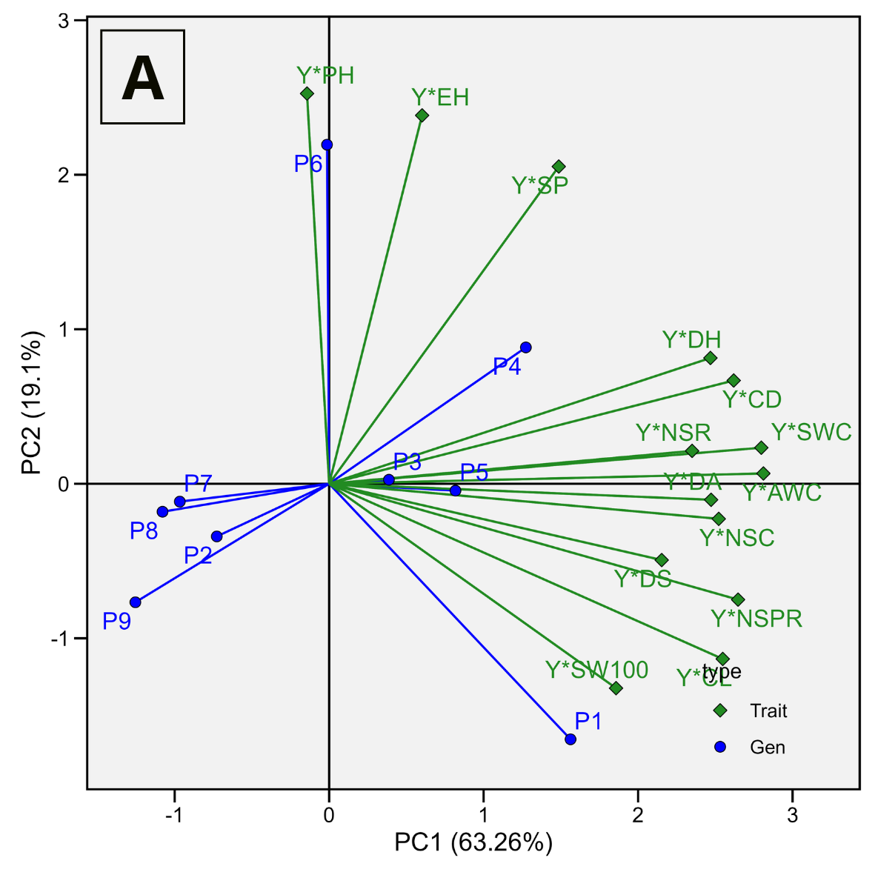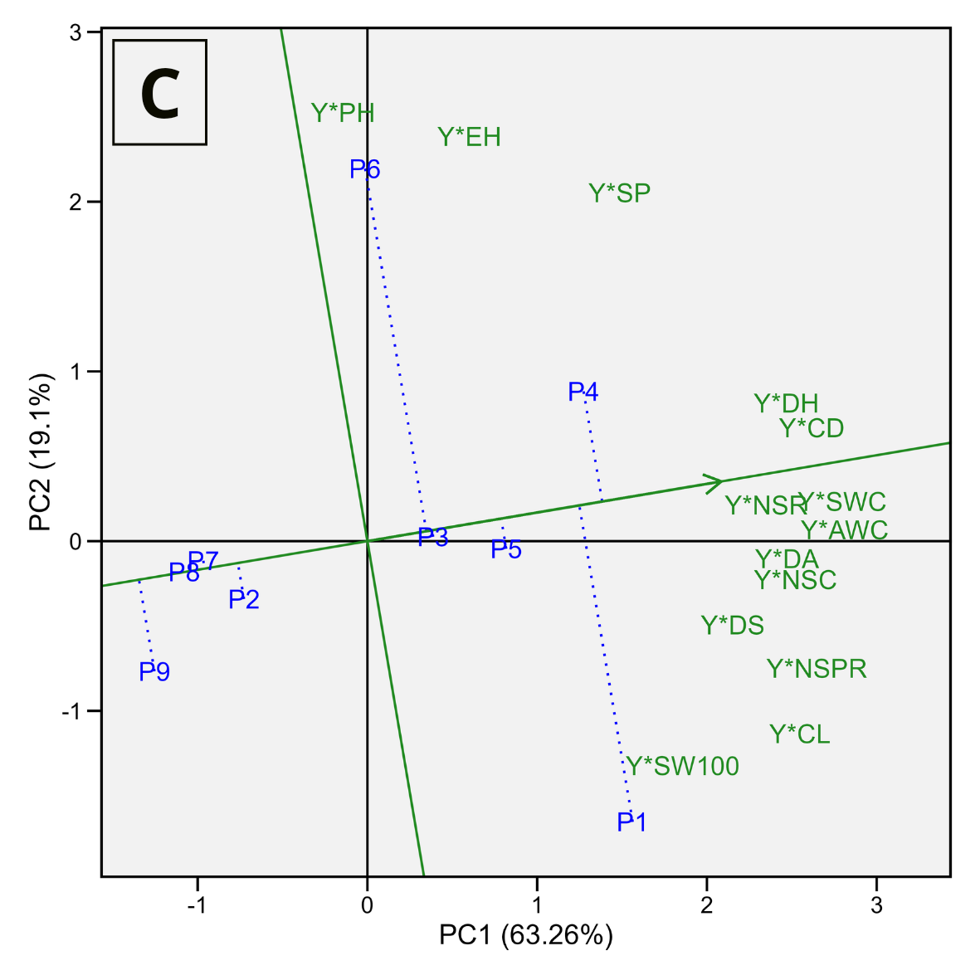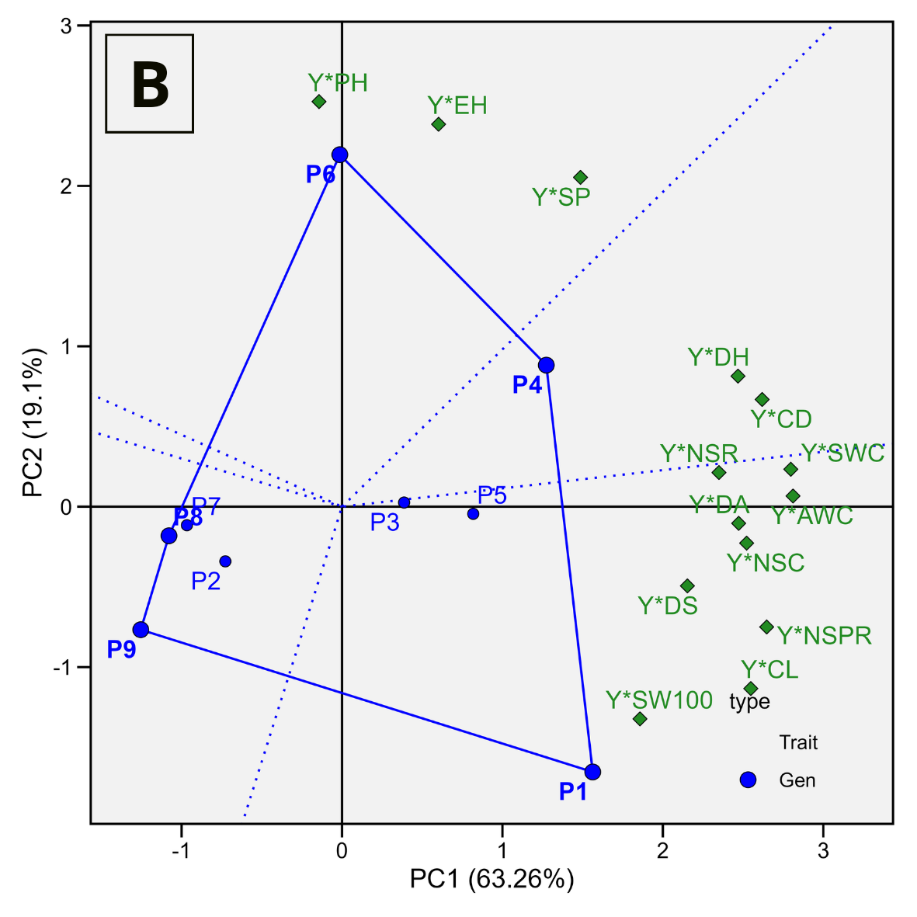

Figure 1. The genotype by yield*trait association view of biplot (A), the which-won-where view of biplot to highlight genotypes with outstanding profiles (B), and the average tester coordination view of the GYT-biplot to rank the genotypes based on their overall superiority and their strengths and weaknesses (C). The biplot was generated using singular value decomposition (SVD) of the standardized GYT matrix with scaling = 1 and centering = 2. A genotype-focused singular value partitioning method (SVP = 1) was applied to emphasize the comparison among genotypes. PH = plant height, and EH = ear height, DA = day of anthesis, DS = day of silking, DH = day of harvest, CL = cob length, CD = cob diameter, AWC = average weight per cob, NSR = number of seed row NSPR = number of seeds per row, 100SW = 100-seed weight, NSC = number of seed per cob, SWC = seed weight per cob, SP = shelling percentage, Y = grain yield.
The which-won-where view showed five main sectors formed by parents P1, P4, P6, P8, and P9 as polygon vertices (Figure 1B). Parent P1 occupied the sector containing Y*DA, Y*DS, Y*CL, Y*NSPR, Y*100SW, Y*AWC, Y*SWC, and Y*NSC, indicating the highest GCA values for those combinations. Parent P4 was associated with Y*CD and Y*DH, while P6 was associated with Y*PH, Y*EH, and Y*SP. These results indicate that each parent possessed specific superiority for particular yield-trait combinations. The Average Tester Coordinate (ATC) view was used to evaluate mean GCA performance and performance consistency across all yield-trait combinations. Parents located farther along the ATC arrow direction had higher average GCA performance, whereas those closer to the ATC line showed more stable performance (Faheem et al., 2023; Yan & Frégeau-Reid, 2018) (Figure 1C). Parent P4 showed the highest average GCA performance because it was positioned at the end of the ATC arrow. Parent P1 also exhibited high performance, although its position farther from the ATC line indicated less balanced performance than P4. Parents P3 and P5 were relatively close to the ATC line, suggesting more stable performance across combinations despite lower mean performance. In contrast, P2, P7, P8, and P9 were positioned opposite the ATC arrow direction, indicating lower average GCA performance. Overall, P4 was superior for harvest age and cob diameter combinations, whereas P1 excelled in several yield-related trait combinations. Based on these results, P1 can be prioritized for improving yield-related traits, while P4 may be selected when breeding objectives focus on harvest age and cob diameter. Both parents are also potential genetic sources for developing open-pollinated, synthetic, or composite varieties because additive gene action contributed substantially to the observed traits. Under predominant additive gene action, selection is more effective because additive effects can be transmitted to progeny (Kar & Halder, 2020). Therefore, selection methods such as ear-to-row and recurrent selection based on general combining ability can be effectively applied (Syukur et al., 2012; Zeyad A. Abdulhamed et al., 2024).
3.2.2 Specific Combining Ability
Analysis of the GYT (Genotype Yield*Trait) biplot based on Specific Combining Ability (SCA) values showed that PC1 explained 74.46% of the variation, while PC2 explained 10.08%. Collectively, the two principal components accounted for 84.54% of the total variation in yield-trait combinations. This indicates that the two-dimensional GYT biplot adequately represented the relationship structure among trait combinations and the response patterns of hybrid combinations. This result is consistent with Cruz et al. (2012), who stated that a biplot is considered appropriate for graphical interpretation when the first two principal components explain more than 70% of the total variation in the data. In the GYT biplot vector display, relationships among trait combinations were interpreted based on the angles between vectors. Acute angles indicate positive correlations, obtuse angles indicate negative correlations, and angles close to 90° indicate weak or no correlation (Figure 2A). This interpretation agrees with Yan et al. (2019), who explained that vector direction and length can be used to evaluate relationships among variables and their contributions to total variation. Most trait combinations were distributed on the positive side of PC1, indicating that PC1 was the main component separating hybrid combinations based on SCA values. The combinations Y*100SW, Y*CL, Y*CD, Y*NSC, Y*AWC, Y*SWC, and Y*NSPR were located in quadrant I, and their close vector directions indicated positive correlations among them. In contrast, Y*DA, Y*JBP, Y*DS, Y*SP, Y*DH, Y*EH, and Y*PH were located in quadrant IV. The vectors of Y*PH and Y*EH were oriented further toward the negative side of PC2, indicating relationship patterns different from those of the combinations in quadrant I.

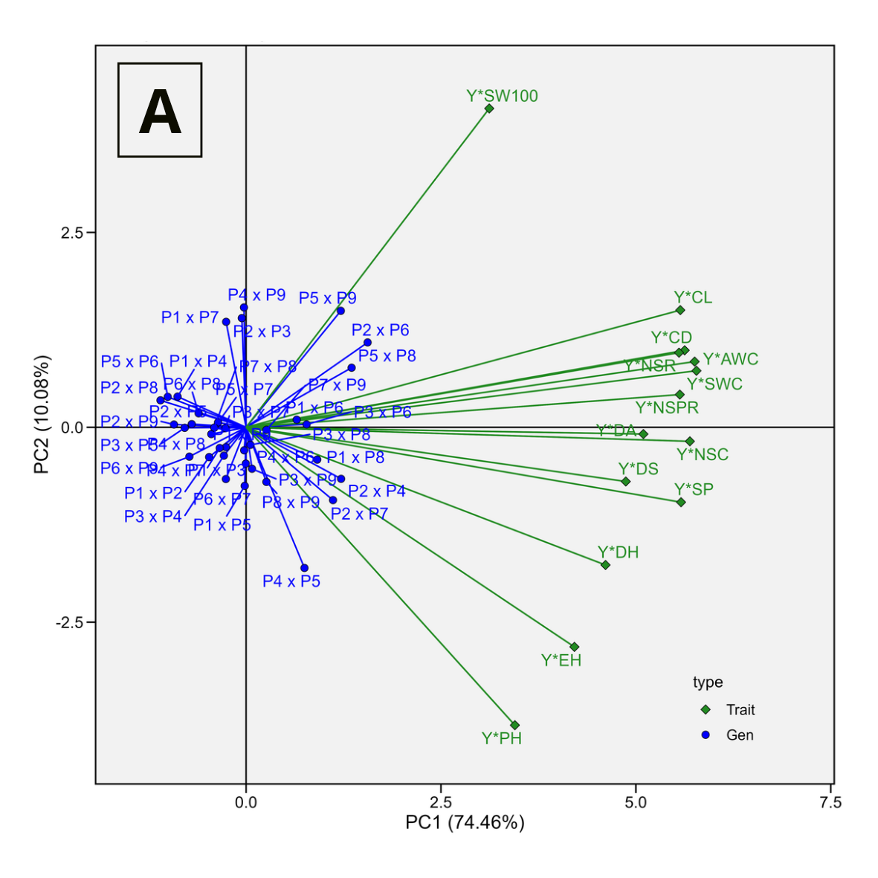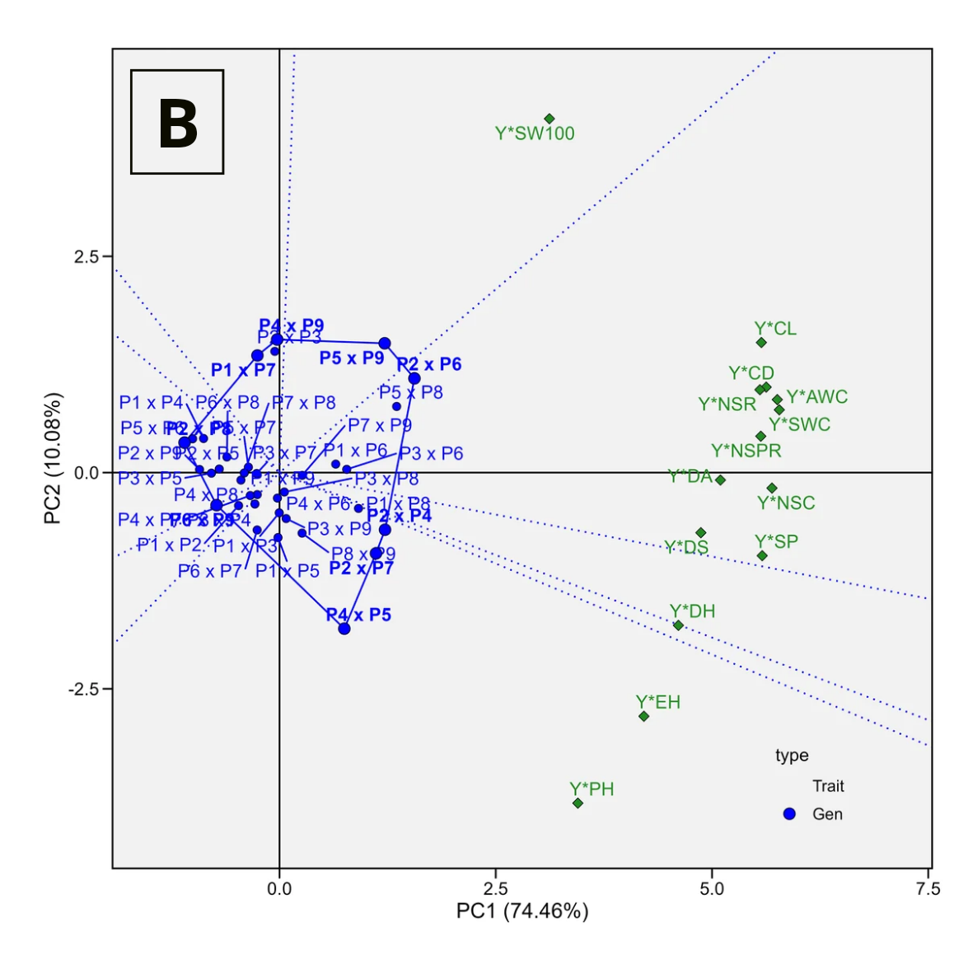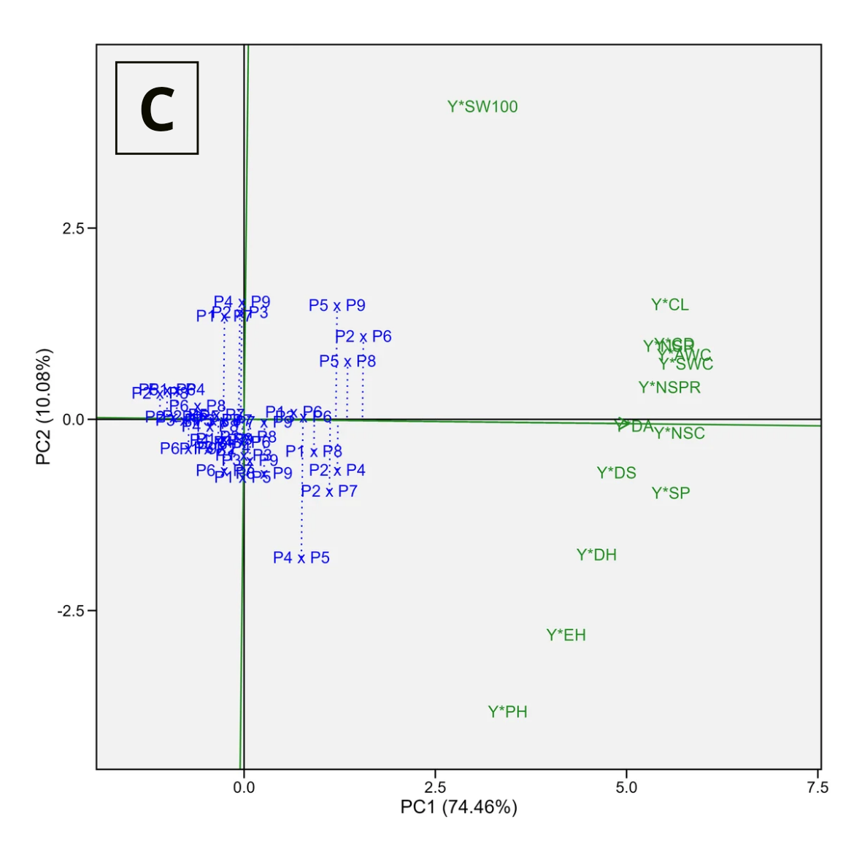

Figure 2. The genotype by yield*trait association view of biplot (A), the which-won-where view of biplot to highlight genotypes with outstanding profiles (B), and the average tester coordination view of the GYT-biplot to rank the genotypes based on their overall superiority and their strengths and weaknesses (C). The biplot was generated using singular value decomposition (SVD) of the standardized GYT matrix with scaling = 1 and centering = 2. A genotype-focused singular value partitioning method (SVP = 1) was applied to emphasize the comparison among genotypes. PH = plant height, and EH = ear height, DA = day of anthesis, DS = day of silking, DH = day of harvest, CL = cob length, CD = cob diameter, AWC = average weight per cob, NSR = number of seed row NSPR = number of seeds per row, 100SW = 100-seed weight, NSC = number of seed per cob, SWC = seed weight per cob, SP = shelling percentage, Y = grain yield.

The which-won-where view revealed specific superiority patterns of hybrid combinations for particular yield-trait combinations, as indicated by SCA values (Figure 2B). An irregular polygon was formed by hybrid combinations located farthest from the origin of the GYT biplot, indicating the highest responsiveness to specific trait combinations (Shojaei et al., 2023; YUE et al., 2023). Eight main sectors were formed, with P4 × P5, P2 × P7, P2 × P4, P2 × P6, P5 × P9, P4 × P9, P1 × P7, P2 × P8, and P6 × P9 serving as polygon vertices. The P5 × P9 combination was located in the sector containing Y*100SW, indicating the highest SCA value for the yield combination at 100-seed weight. Meanwhile, P2 × P6 dominated the sector comprising Y*CL, Y*CD, Y*NSC, Y*AWC, Y*SWC, Y*NSPR, Y*DA, and Y*JBP, suggesting strong potential to improve yield through these yield-component traits.
The combination P2 × P4 was associated with the sector containing Y*DS and Y*SP, whereas P2 × P7 was associated with YDH. The combination P4 × P5 was associated with Y*EH and Y*PH. Meanwhile, P4 × P9, P1 × P7, P2 × P8, and P6 × P9 also appeared as polygon vertices but were not clearly associated with specific trait combinations. This indicates that these hybrids were responsive but did not exhibit clear superiority for the observed trait combinations. The Average Tester Coordinate (ATC) view was used to evaluate mean SCA performance and performance stability across all trait combinations (Figure 2C). Hybrid combinations positioned along the direction of the ATC arrow had higher average SCA values, whereas those located closer to the ATC line showed more stable performance (Hassani et al., 2024; Stansluos et al., 2023). Based on the ATC direction, P2 × P6 had the highest average SCA value because it was positioned farthest along the arrow direction. The combinations P5 × P8, P2 × P4, P5 × P9, and P2 × P7 were also oriented toward high performance, indicating relatively high average SCA values. However, P2 × P6, P5 × P9, P5 × P8, and P2 × P7 were located relatively far from the ATC line, indicating less uniform performance across trait combinations. In contrast, P3 × P6 and P1 × P6 were positioned closer to the ATC line, indicating more stable performance despite lower average SCA values compared with P2 × P6. Hybrid combinations located opposite the ATC arrow direction showed lower average SCA values. Overall, P2 × P6 was identified as the hybrid combination with the highest average SCA performance. Based on its superiority across several yield-related trait combinations, P2 × P6 can be considered a promising genetic source for developing pure-line varieties that leverage heterosis. In addition, this combination may be useful in recurrent selection programs based on specific combining ability, which exploit the effects of non-additive gene action (Akinwale et al., 2021).

4. Limitations and Future Directions
However, this study has several limitations that should be considered when interpreting the results. The experiment was conducted over a single growing season at a single experimental location, with only two replications. Therefore, multi-environment testing was not performed, and genotype × environment (G × E) interactions could not be evaluated. Consequently, the estimated combining ability and genetic parameters should be interpreted in the context of the study's environmental conditions. In addition, this study evaluated only S4 diallel-derived progenies, whereas earlier selfing generations (S0–S3) were not comprehensively investigated. Future studies should validate these findings through multi-location and multi-season trials with greater replication to evaluate G × E interactions and the stability of combining ability. Comparative evaluations across different selfing generations and under contrasting stress environments, together with the integration of molecular marker-assisted approaches or genomic prediction, would further improve the accuracy of parent and hybrid selection.

5. Conclusion
This study provides a comprehensive evaluation of combining ability and genetic parameters in S4 diallel-derived maize progenies, providing scientific evidence on the relative contributions of additive and non-additive gene action in advanced selfing generations. The novelty of this study lies in the use of S4 diallel-derived progenies to identify superior parents and hybrid combinations at an advanced stage of inbreeding. General combining ability analysis identified P4 and P1 as the best parents based on their average GCA performance in the ATC view, each exhibiting distinct advantages. P4 showed superior combining ability for yield associated with cob diameter and days of harvest, whereas P1 excelled for several yield-related traits, including days of anthesis, days of silking, cob length, number of seed rows, number of seeds per row, 100-seed weight, seed weight per cob, number of seeds per cob, and shelling percentage. These parents are promising genetic sources for recurrent selection and the development of synthetic or open-pollinated maize varieties.
Specific combining ability analysis identified P2 × P6 as the best hybrid combination based on its average SCA performance in the ATC view. This cross showed superiority for yield associated with cob length, cob diameter, number of seeds per cob, shelling percentage, seed weight per cob, number of seed rows, days of anthesis, and number of seeds per row. In addition, P2 × P4 showed superiority for yield associated with days to silking and shelling percentage. These hybrids are promising candidates for further multi-environment evaluation in hybrid breeding programs. The S₄ maize population exhibited substantial genetic variability for all evaluated traits. Days to anthesis, cob length, and number of seeds per row showed high narrow-sense heritability. Most traits were predominantly controlled by additive gene action, whereas the number of seeds per cob and grain yield were mainly influenced by non-additive gene action.
Declaration of Generative AI and AI-Assisted Technologies in the Writing Process
During the preparation of this work, the author(s) used ChatGPT by OpenAI to assist with language improvement, translation, and manuscript organization. After using this tool, the author(s) reviewed and edited the content as needed and took full responsibility for the content of the published article.
Authorship Contribution Statement
Anggada Bima Satya Wibowo: Conceptualization, Investigation, Data curation, Formal analysis, Visualization, Writing – original draft, Writing – translation, and Manuscript finalization. Conducted maize cultivation during the experiment, collected and analyzed observational data, prepared and wrote the manuscript, translated the manuscript from Indonesian to English, and finalized the manuscript preparation. Darmawan Saptadi: Validation, Writing – review & editing. Contributed through manuscript review, corrections, and additional recommendations for manuscript improvement. Budi Waluyo: Methodology, Validation, Supervision, Writing – review & editing. Provided suggestions on the experimental design, determined observation variables, and revised the manuscript.
Declaration of Competing Interest
The authors declare that they have no known competing financial interests or personal relationships that could have appeared to influence the work reported in this paper.
Acknowledgements (Optional)
This study was financially supported by PT. Sukses Seed Sentosa. The authors gratefully acknowledge Universitas Brawijaya for providing research facilities and academic guidance. The authors also express their sincere appreciation to the Fast-Track Program at Universitas Brawijaya for its support during this study.
References
Acquaah, G. (2012). Principles of Plant Genetics and Breeding (Second). Wiley-Blackwell.
Akinwale, R. O., Eze, C. E., Traore, D., & Menkir, A. (2021). Detection of Non-Additive Gene Action within Elite Maize Populations Evaluated in Contrasting Environments under Rainforest Ecology in Nigeria. Crop Breeding, Genetics and Genomics, 3(1). https://doi.org/10.20900/cbgg20210003
Akinwale, R. O., Fakorede, M. A. B., Badu-Apraku, B., & Oluwaranti, A. (2014). Assessing the usefulness of GGE biplot as a statistical tool for plant breeders and agronomists. Cereal Research Communications, 42(3), 534–546. https://doi.org/10.1556/CRC.42.2014.3.16
Alam, M. A., Rahman, M., Ahmed, S., Jahan, N., Khan, M. A.-A., Islam, M. R., Alsuhaibani, A. M., Gaber, A., & Hossain, A. (2022). Genetic Variation and Genotype by Environment Interaction for Agronomic} Traits} in Maize (Zea mays L.) Hybrids. Plants, 11(11), 1522. https://doi.org/10.3390/plants11111522
Azrai, M., Aqil, M., Efendi, R., Andayani, N. N., Suwardi, Zainuddin, B., Pabendon, M. B., Sitaresmi, T., Anshori, M. F., Riadi, M., Yasin, M., Laurenze, R., Bahtiar, Suwarti, & Syam, A. (2025). Integrating multi-trait and multi-index approaches for identifying drought-tolerant tropical maize genotypes. Frontiers in Sustainable Food Systems, 9, 1608307. https://doi.org/10.3389/fsufs.2025.1608307
Bhullar, G. S., Gill, K. S., & Khehra, A. S. (1979). Combining ability analysis over F1-F5 generations in diallel crosses of bread wheat. Theoretical and Applied Genetics, 55(2), 77–80. https://doi.org/10.1007/BF00285194
BPS. (2026). Jumlah curah hujan di Kota Malang (milimeter (mm)). https://malangkota.bps.go.id/id/statistics-table/2/NTA4IzI=/jumlah-curah-hujan-di-kota-malang.html
Brown, J., Caligari, P., & Campos, H. (2014). Plant breeding. John Wiley \& Sons.
Chaudhary, R. C. (2019). Introductory Principles of Plant Breeding (Second). Oxford & IBH Publishing Co. Pvt. Ltd.
Cruz, C. D., Regazzi, A. J., & Carneiro, P. C. S. (2012). Biometric models applied to genetic improvement. Viçosa, MG: UFV, 1, 514.
Cyplik, A., Sobiech, A., Tomkowiak, A., & Bocianowski, J. (2022). Genetic Parameters for Selected Traits of Inbred Lines of Maize (Zea mays L}.). Applied Sciences, 12(14), 6961. https://doi.org/10.3390/app12146961
Damtie, Y., Assefa, G., & Mulualem, T. (2021). Genetic variability, heritability, trait associations and path coefficient analysis of maize (Zea mays L.) inbreed lines. Journal of Current Opinion in Crop Science, 2(1), 86–94. https://doi.org/10.62773/jcocs.v2i1.22
Elayaraja, K., Gadag, R. N., Kumari, J., & Mishra, U. (2018). Combining ability and gene action in experimental hybrids of Sweet Corn ( Zea mays var. saccharata ). Indian Journal of Horticulture, 75(1), 64. https://doi.org/10.5958/0974-0112.2018.00011.7
Faheem, M., Arain, S. M., Sial, M. A., Laghari, K. A., & Qayyum, A. (2023). Genotype by yield*trait (GYT) biplot analysis: a novel approach for evaluating advance lines of durum wheat. Cereal Research Communications, 51(2), 447–456. https://doi.org/10.1007/s42976-022-00298-7
Fasahat, P. (2016). Principles and Utilization of Combining Ability in Plant Breeding. Biometrics & Biostatistics International Journal, 4(1), 1–24. https://doi.org/10.15406/bbij.2016.04.00085
Hassani, M., Mahmoudi, S. B., Saremirad, A., & Taleghani, D. (2024). Genotype by environment and genotype by yield*trait interactions in sugar beet: analyzing yield stability and determining key traits association. Scientific Reports, 13(1), 23111. https://doi.org/10.1038/s41598-023-51061-9
He, Z.-H., Xiao, Y., Lv, Y.-W., Yeh, F. C., Wang, X., & Hu, X.-S. (2023). Prediction of Genetic Gains from Selection in Tree Breeding. Forests, 14(3), 520. https://doi.org/10.3390/f14030520
Hosseini, S. M. S., Shiri, M., Mostafavi, K., Mohammadi, A., & Miri, S. M. (2025). Genetic analysis and association detection of agronomic traits in maize genotypes. Scientific Reports, 15(1), 399. https://doi.org/10.1038/s41598-024-84471-4
Kar, D. K., & Halder, S. (2020). Plant Breeding, Biometry \& Biotechnology. New Central Book Agency.
Kearsey, M. J., & Pooni, H. (1996). Genetical analysis of quantitative traits. Garland Science.
Kendal, E. (2019). Comparing durum wheat cultivars by genotype × yield ×trait and genotype × trait biplot method. Chilean Journal of Agricultural Research, 79(4), 512–522. https://doi.org/10.4067/S0718-58392019000400512
Merrick, L. F., Glover, K. D., Yabwalo, D., & Byamukama, E. (2020). Use of Genotype by Yield*Trait (GYT) Analysis to Select Hard Red Spring Wheat with Elevated Performance for Agronomic and Disease Resistance Traits. Crop Breeding, Genetics and Genomics, 2(2). https://doi.org/10.20900/cbgg20200009
Mufidah, N., Sugiharto, A. N., & Waluyo, B. (2021). Assessment of combining ability in purple corn parents under line × tester mating design using GGE biplot. Biodiversitas Journal of Biological Diversity, 22(10), 4545–4554. https://doi.org/10.13057/biodiv/d221048
Mutimaamba, C., Macrobert, J., Cairns, J. E., Magorokosho, C. E., Ndhlela, T., Mukungurutse, C., Minnaar-Ontong, A., & Labuschagne, M. T. (2017). Diallel analysis of acid soil tolerant and susceptible maize inbred lines for grain yield under acid and non-acid soil conditions. Euphytica, 213(4). https://doi.org/10.1007/s10681-017-1877-5
Nguyen, H. T. H., Chen, Z.-Q., Fries, A., Berlin, M., Hallingbäck, H. R., & Wu, H. X. (2022). Effect of additive, dominant and epistatic variances on breeding and deployment strategy in Norway spruce. Forestry: An International Journal of Forest Research, 95(3), 416–427. https://doi.org/10.1093/forestry/cpab052
Oliveira, T. R. A. de, Gravina, G. de A., Oliveira, G. H. F. de, Araújo, K. C., Araújo, L. C. de, Daher, R. F., Vivas, M., Gravina, L. M., & Cruz, D. P. da. (2018). The GT biplot analysis of green bean traits. Ciência Rural, 48(6), e20170757. https://doi.org/10.1590/0103-8478cr20170757
Peixoto, M. A., Evangelista, J. S. P. C., Coelho, I. F., Carvalho, L. P., Farias, F. J. C., Teodoro, P. E., & Bhering, L. L. (2022). Genotype selection based on multiple traits in cotton crops: The application of genotype by yield*trait biplot. Acta Scientiarum. Agronomy, 44, e54136. https://doi.org/10.4025/actasciagron.v44i1.54136
Putri, L. D. N., Saptadi, D., & Waluyo, B. (2022). Analisis Daya Gabung dan Aksi Gen Jagung (Zea mays L) menggunakan Rancangan Perkawinan Line x Tester. Agriprima : Journal of Applied Agricultural Sciences, 6(2), 191–201. https://doi.org/10.25047/agriprima.v6i2.492
Rouf Shah, T., Prasad, K., & Kumar, P. (2016). Maize A potential source of human nutrition and health: A review. Cogent Food & Agriculture, 2(1), 1166995. https://doi.org/10.1080/23311932.2016.1166995
Sary, D. N., Badriyah, L., Sihombing, R. D., Syauqy, T. A., Mustikarini, E. D., Prayoga, G. I., Santi, R., & Waluyo, B. (2022). Estimation of Heritability and Association Analysis of Agronomic Traits Contributing to Yield on Upland Rice ( Oryza sativa L.). Plant Breeding and Biotechnology, 10(4), 232–243. https://doi.org/10.9787/PBB.2022.10.4.232
Shirinpour, M., Atazadeh, E., Bybordi, A., Monirifar, H., Amini, A., Hossain, M. A., Aharizad, S., & Asghari, A. (2023). Gene action and inheritance of grain yield and root morphological traits in hybrid maize grown under water deficit conditions. South African Journal of Botany, 161, 180–191. https://doi.org/10.1016/j.sajb.2023.08.016
Shojaei, S., Mostafavi, K., Ansarifard, I., Bihamta, M., Zeinalzadeh-Tabrizi, H., Omrani, A., Göre, M., & Mousavi, S. M. N. (2023). Comparison of genotype × trait and genotype × yield-trait biplots in Sunflower cultivars. International Journal of Agriculture Environment and Food Sciences, 7(1), 136–147. https://doi.org/10.31015/jaefs.2023.1.17
Singh, D. P., Singh, A. K., & Singh, A. (2021). Plant breeding and cultivar development. Academic Press.
Singh, R. K., & Chaudhary, B. D. (1981). Biometrical methods in quantitative genetic analysis.
Stansfield, R. (1983). Genetika. Terjemahan oleh: Mohidin A, Apandi, Lanny T. 1991. Erlangga. Jakarta, 182.
Stansluos, A. A. L., Öztürk, A., Niedbała, G., Türkoğlu, A., Haliloğlu, K., Szulc, P., Omrani, A., Wojciechowski, T., & Piekutowska, M. (2023). Genotype–Trait (GT) Biplot Analysis for Yield and Quality Stability in Some Sweet Corn (Zea mays L. saccharata Sturt.) Genotypes. Agronomy, 13(6), 1538. https://doi.org/10.3390/agronomy13061538
Sumanth, V., Bg, S., Ram, J., & Srujana, G. (2017). Estimation of genetic variability, heritability and genetic advance for grain yield components in rice (Oryza sativa L.). Journal of Pharmacognosy and Phytochemistry, 6(4), 1437–1439.
Supriadi, D., Bimantara, Y. M., Zendrato, Y. M., Widaryanto, E., Kuswanto, K., & Waluyo, B. (2024). Assessment of genotype by environment and yield performance of tropical maize hybrids using stability statistics and graphical biplots. PeerJ, 12, e18624. https://doi.org/10.7717/peerj.18624
Supriadi, D., Bimantara, Y. M., Zendrato, Y. M., Widaryanto, E., Kuswanto, K., & Waluyo, B. (2025). Associations and Multi-Traits Selection for Identifying Superior and Stable Maize Hybrids (Zea mays L.) Under Tropical Regions. Caraka Tani: Journal of Sustainable Agriculture, 41(1), 17. https://doi.org/10.20961/carakatani.v41i1.107896
Syukur, M., Sujiprihati, S., & Yunianti, R. (2012). Teknik Pemuliaan Tanaman. Penebar Swadaya Grup.
Tesfaye, D., Abakemal, D., & Habte, E. (2021). Genetic variability, heritability and genetic advance estimation of highland adapted maize (Zea mays L.) genotypes in Ethiopia. Journal of Current Opinion in Crop Science, 2(2), 184–191. https://doi.org/10.62773/jcocs.v2i2.57
Viana, J. M. S. (2023). The impact of epistasis in the heterosis and combining ability analyses. Frontiers in Plant Science, 14(April), 1–11. https://doi.org/10.3389/fpls.2023.1168419
Waghmare, P., Dahat, D., Amolic, V., Shinde, G., Patil, M., Shinde, S., & Dhonde, S. (2025). Combining ability for maize inbreds lines for yield and yield traits. International Journal of Advanced Biochemistry Research, 9(3), 213–223. https://doi.org/10.33545/26174693.2025.v9.i3c.3920
Welderufael, S., Abay, F., Ayana, A., & Amede, T. (2023). Genotype by Trait (GT) and Genotype by Yield*Traits (GYT) Analysis of Sorghum Landraces in Tigray, Northern Ethiopia. Crop Breeding, Genetics and Genomics, 5(2). https://doi.org/10.20900/cbgg20230002
Yan, W., & Frégeau-Reid, J. (2018). Genotype by Yield*Trait (GYT) Biplot: a Novel Approach for Genotype Selection based on Multiple Traits. Scientific Reports, 8(1), 8242. https://doi.org/10.1038/s41598-018-26688-8
Yan, W., Frégeau-Reid, J., Mountain, N., & Kobler, J. (2019). Genotype and Management Evaluation Based on Genotype by Yield*Trait (GYT) Analysis. Crop Breeding, Genetics and Genomics, 1(2). https://doi.org/10.20900/cbgg20190002
YUE, H.-W., HAN, X., WEI, J.-W., ZHENG, S.-H., XIE, J.-L., CHEN, S.-P., PENG, H.-C., & BU, J.-Z. (2023). Comprehensive evaluation of maize hybrids tested in Huang-Huai-Hai summer maize regional trial based on GYT biplot analysis. Acta Agronomica Sinica, 49(5), 1231–1248. https://doi.org/10.3724/SP.J.1006.2023.23035
Zanetta, C. U., Y. Rafii, M., Jaafar, J. N., Warkentin, T. D., Waluyo, B., & Ramlee, S. I. (2025). Variability and assessment of interrelationships among yield and yield‐related characters of pea accessions under the influence of high temperature. New Zealand Journal of Crop and Horticultural Science, 53(4), 870–888. https://doi.org/10.1080/01140671.2023.2180760
Zeyad A. Abdulhamed, Nihad.M. Abood, & Abdulsamad. H. Noaman. (2024). Recurrent selection for general and specific combining ability in maize. IRAQI JOURNAL OF AGRICULTURAL SCIENCES, 55(Special), 99–110. https://doi.org/10.36103/ijas.v55iSpecial.1889

