Performance Test of Vegetative Characteristics of Crossed Rice (Oryza sativa L.) Lines of Ciherang Variety x B11143D Line in Telagasari, Karawang Regency, Indonesia

Utari Damayanti^{1♥}, Ani Lestari¹, Vera Octavia Subardja¹, Toto Hadiarto², Dani Satyawan², Amalia Prihaningsih², Wening Enggarini²
¹Agrotechnology, Faculty of Agriculture Singaperbangsa Karawang University, Karawang Regency.

²Research Center for Genetic Engineering, Research Organization for Life Sciences and Environment, National Research and Innovation Agency, Jl. Raya Bogor Km 46, Cibinong, Bogor, West Java, Indonesia.

♥Email correspondence: utari6588@gmail.com; weni003@brin.go.id

Abstract. One way to increase the genetic diversity of Ciherang as the superior variety is to cross Ciherang with the donor B11143D line as New Type Plant (NTP) rice. This study aimed to obtain Ciherang X B11143D lines with the best vegetative characteristics in the field. The research was conducted in rice fields in Talagasari Village, Telagasari District, Karawang Regency, from May to September 2023. This experiment used a single-factor Randomized Block Design (RBD) with three replications of 22 treatments, consisting of 19 Ciherang X B11143D lines and three comparison varieties. The effect of treatment was studied using analysis of variance. If the F test at the 5% level was significant, then it was continued with the DMRT test (Duncan Multiple Range Test) at the 5% level. The results showed that the rice lines significantly influenced the vegetative characters of Ciherang X B11143D lines in Telagasari, Karawang Regency. Based on the observed characters, several lines were selected i.e. 124.2.3, 94.3.3, and 20.4.4 lines. Those three selected lines as backcrossing lines performed similarly compared to Ciherang as recurrent parent and inherited several important traits for rising productivity from the B11143D line as donor parent, namely the length and area of flag leaf, the total number of tillers, and the number of productive tillers, which were significantly higher than Ciherang.

Keywords: B11143D Line, Ciherang Variety, Field test, Rice, and Vegetative characteristics

INTRODUCTION
Rice is a staple food in Indonesia. Its production was 54.65 million tons of Milled Dry Grain (MDG) in 2020, an increase of 45.17 thousand tons or 0.084 percent compared to that in 2019. According to the 2021 strategic food balance prognosis guide data (Tarwyati, 2021), rice consumption of Indonesian people in 2021 is 108,940 kg/cap/year. This is a tough challenge for the agricultural sector, because with the increase in population, the demand for rice will increase in number. This implies that there is a need to increase production, quality, and diversity of rice varieties.
One of superior varieties of rice plants that have a large contribution in national rice production is Ciherang. In addition to its high yield potential, the shape of Ciherang rice grains is ideal in clear yellow color with fluffier rice, making this variety always in demand by farmers and consumers. According to Suprihatno et al. (2007), the production number of tillers in Ciherang variety is 20-25 stems but not all of them can be productive. In order to overcome problems with specific biotic and abiotic stress, Ciherang may be improved through increasing yield potential through crosses with donor New Type Rice plants (NTR). It is hoped that superior traits related to the yield potential of donor enter the Ciherang variety (Susilowati et al., 2014).
The effort to introduce new traits from the B11143D strain into the genome of Ciherang variety was carried out through backcross method. For efficient selection process in each backcross, genetic markers can be used to help breeders select the desired genotype based on the introgressed donor chromosome segments or referred to as CSSL (Chromosome Segment Substitution Lines) (Futura et al., 2014).
Crossing Ciherang varieties with B11143D strains aims to increase genetic diversity and obtain progenies with better performance and/or yield than Ciherang varieties. Therefore, it is necessary to conduct further research on the test of vegetative behavior of strains resulting from the cross of Ciherang variety x B11143D strain in the field.

METHODS
This research was conducted in rice fields in Talagasari Village, Telagasari Subdistrict, Karawang, West Java from May to September 2023. The materials used were 22 genotypes consisting of 19 progenies from the cross of Ciherang x B11143D and 3 comparing varieties/line (Ciherang, B11143D line, and Inpari 32), where each sample consisted of 180 seeds. Urea fertilizer, NPK fertilizer, herbicides, pesticides, and molluscicides were also used. Vegetative characters observed were plant height, flag leaf length, flag leaf area, flowering age, total tillers, and total productive tillers.
The research method used is an experimental method using a single-factor Randomized Group Design (RGD), with the further test used is the DMRT (Duncan Multiple Range Test) further test. In this study there were 22 treatments, each with 3 replications. The experimental plot area of each treatment was 2.5 x 1.5 m with a spacing of 25 x 25 cm. The total number of experimental plots was 66 experimental plots. The following treatment codes and descriptions can be seen in Table 1.
Table 1. Name of progenies from the cross of Ciherang x B11143D strain and other samples tested in Karawang Regency

No. | Name of Strain/Variety | Genomic insertion position of donor parent (B11143D strain) | Field Code
1 | 1.2.4 | Kromosom 1 | A
2 | 1.5.1 | Kromosom 1 | B
3 | 2.3.3 | Kromosom 1 | C
4 | 11.2.1 | Kromosom 1 | D
5 | 15.1.3 | Kromosom 4 | E
6 | 15.2.2 | Kromosom 4 | F
7 | 20.4.4 | Kromosom 6 | G
8 | 22.4.3 | Kromosom 6 | H
9 | 70.3.2 | Kromosom 1 | I
10 | 72.2.3 | Kromosom 1 | J
11 | 94.3.3 | Kromosom 1 | K
12 | 96.5.4 | Kromosom 1 | L
13 | 100.5.1 | Kromosom 2 | M
14 | 102.5.5 | Kromosom 2 | N
15 | 105.5.1 | Kromosom 5 | O
16 | 112.1.3 | Kromosom 6 | P
17 | 112.4.5 | Kromosom 6 | Q
18 | 115.1.5 | Kromosom 7 | R
19 | 124.2.3 | Kromosom 11 | S
20 | Ciherang | Pembanding | T
21 | B11143D Strain | Pembanding | U
22 | Inpari 32 | Pembanding | V

The implementation of this research has several experimental stages, namely land management, nursery and seeding, planting, fertilization, weeding, control of plant disrupting organisms, and irrigation. In this study, several observations of vegetative characters were made, namely plant height, flag leaf length, flag leaf area, flowering age, total tillers, and productive tillers.

RESULTS AND DISCUSSION
The plants planted in this study are strains of the crossing of Ciherang varieties x B11143D strains through the backcross method that have been selected. The strains are the BC3F6 generation of selection results from preliminary tests conducted at KP Sukamandi in 2017.
The results of the diversity analysis of the 22 rice genotypes on 6 parameters observed (plant height, flag leaf length, flag leaf area, flowering age, total tillers, and total productive tillers) are shown in Table 2. There are significant differences between genotypes on all parameters observed. The coefficient of variation ranged from 0.54% to 3.55%. Based on Gomez and Gomez (2010), the coefficient of variation of less than 20% indicates good data diversity and valid data.

Tabel 2. Results of analysis variance in all observating parameters.
Parameters Observed | F-Count | CV (%)
Plant Height | 32,385* | 0,77
Flag Leaf Length | 33,109* | 0,79
Flag Leaf Area | 86,451* | 0,54
Flowering Age | 31,389* | 0,86
Total Tillers | 28,927* | 2,01
Productive Tillers | 10,665* | 3,55
F-Table 5% | 1,813
Description: * = Significantly different at 5% level; CV=Coefficient of Variance

Table 3. The results of the DMRT test on the mean values of the parameters of plant height (PH in cm), flag leaf lenght (FLL in cm) and flag leaf area (FLA in cm²).
Strains/Variety | PH | FLL | FLA
1.2.4 | 112,483 def | 49,533 def | 99,067 def
1.5.1 | 109,267 h | 48,367 h | 96,733 h
2.3.3 | 113,583 bcde | 49,600 bcde | 99,200 bcde
11.2.1 | 113,800 bcd | 49,667 bcd | 99,333 bcd
15.1.3 | 110,650 gh | 49,883 gh | 99,767 gh
15.2.2 | 112,983 cde | 49,667 cde | 99,333 cde
20.4.4 | 114,400 bc | 50,283 bc | 100,567 bc
22.4.3 | 113,800 bcd | 49,500 bcd | 99,000 bcd
70.3.2 | 111,950 efg | 49,883 efg | 99,767 efg
72.2.3 | 113,550 bcde | 49,533 bcde | 99,067 bcde
94.3.3 | 114,733 b | 50,383 b | 100,767 b
96.5.4 | 112,467 def | 49,683 def | 99,367 def
100.5.1 | 112,967 cde | 49,750 cde | 99,500 cde
102.5.5 | 110,700 gh | 48,367 gh | 96,733 gh
105.5.1 | 110,900 fg | 48,317 fg | 96,567 fg
112.1.3 | 112,450 def | 49,633 def | 99,267 def
112.4.5 | 113,883 bcd | 49,783 bcd | 99,633 bcd
115.1.5 | 113,850 bcd | 49,467 bcd | 98,933 bcd
124.2.3 | 115,283 b | 50,383 b | 100,767 b
Ciherang | 114,533 bc | 49,200 bc | 98,467 bc
B11143D Strain | 124,350 a | 55,033 a | 111,433 a
Inpari 32 | 113,767 bcd | 49,417 bcd | 98,833 bcd
Description: Mean values followed by different letters in each column indicate that there are
significant differences at the 5% DMRT level.

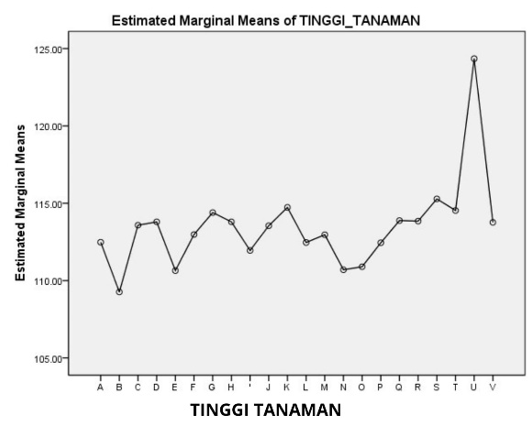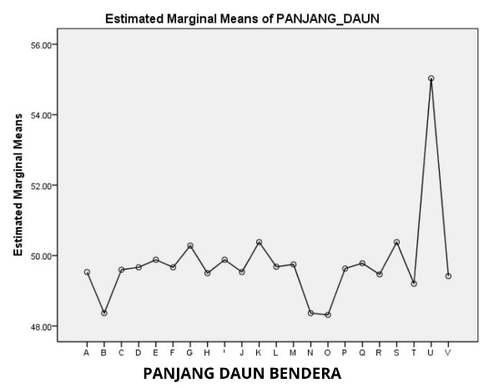
Image 1. Data pattern of plant height and flag leaf length in rice
Plant Height
The results of DMRT test analysis in Table 3 showed that the progenies of Ciherang x B11143D cross that had the best plant height was line 124.2.3 with an average plant height of 115.283 cm followed by line 94.3.3 with an average plant height of 114.733 cm and line 20.4.4 with an average plant height of 114.400 cm. The character of plant height of the three strains most resembles Ciherang.
Figure 1 shows that the plant height of the progenies resulting from the backcross of Ciherang x B11143D ranged from 109 to 115 cm, within the height range of the comparing varieties of Ciherang and Inpari 32. According to Daradjat (1999) the quality and quantity of a plant's yield is determined by the genetic factors of the plant. The backcross method still maintains and does not eliminate the good characters in the parental restorer (Hasmeda et al., 2017). The plant height character of the restorer parent, i.e Ciherang variety, is likely to remain in the genome compared to the that of the B11143D line as the donor parent.
Based on Siregar (1981), rice plant height is divided into three groups: short plants with height of less than 115 cm, medium around 11 - 125 cm and high which is more than 125 cm. In Figure 1, it can be seen that B11143D line is the tallest compared to others. According to Abdullah et al. (2017), the B11143D is a new type of rice with a plant height that is classified as medium. While the progenies resulting from the cross of Ciherang x B11143D had short plant height criteria, similar to Ciherang and Inpari 32.

Flag Leaf Length
In the observation of flag leaf length parameter, the results of 5% DMRT test analysis (Table 3) showed that the best average flag leaf length were lines 94.3.3 and 124.2.3 with the same value of 50.383 cm, followed by line 20.4.4 with a value of 50.283 cm. The three strains had flag leaf length greater than Ciherang, but not significantly different.
In the distribution of flag leaf length Image 1 shows that the length of flag leaf of rice progenies of Ciherang x B11143D had higher values than Ciherang. Lines 94.3.3, 124.2.3 and 20.4.4 which has the best average length of flag leaf is thought to be due to the introgression of genes from the B11143D line as a donor parent. In accordance with the statement of Elfianis (2020) that backcrossing can carry good traits from the donor elders.
The results of research by Susilowati et al. (2014) showed that the B11143D strain has a longer flag leaf compared to the Ciherang variety. The B11143D strain is one of the new type of rice strains that has agronomic characters such as flowering age, flag leaf area, number of grains per panicle and 1000-grain weight that are superior to the Ciherang variety.

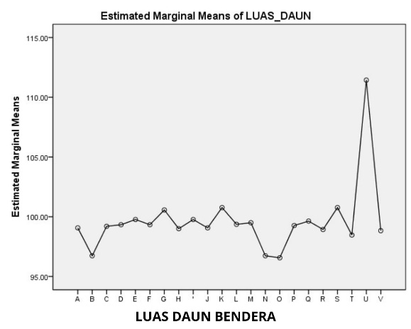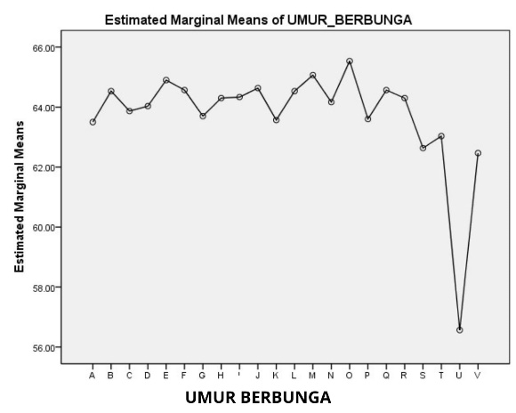
Image 2. Data pattern of flag leaf area and flowering age in rice.
Flag Leaf Area
The results of the 5% DMRT test analysis (Table 3) showed that the average value of flag leaf area in the strains of Ciherang x B11143D cross was best found in Strain 94.3.3 and Strain 124.2.3 with the same value of 100.767 cm2, followed by Strain 20.4.4 at 100.567 cm2. The three strains have a larger flag leaf area than Ciherang, but not significantly different.
In the distribution of flag leaf area Image 2 shows that the flag leaf area of rice progenies resulting from the cross of Ciherang x B11143D had higher value than Ciherang as a restorer parent. According to Husna et al. (2022) the characteristics of the donor parent are integrated into the genomic background of the restorer parent. Line B11143D has the largest flag leaf area compared to others. This is in line with the results of research by Susilowati et al. (2014) that demonstrated that B11143D had a larger flag area compared to the flag leaf area of Ciherang variety.
The effect of flag leaf length is in line with the growth of rice flag leaf width. Afrijon et al. (2021) argued that the longer the flag leaf, the more the flag leaf area increased. Flag leaf functions in improving photosynthetic performance and plays an important role in plant yield (Karim, 2014). Therefore, the characters of flag leaf length and area are important as observation parameters for rice productivity.

Table 4. The results of the DMRT test on the mean value of the parameters of flowering age (das), total tillers and productive tillers (stem at a clump).
Strains/Variety | FA | TT | PT
1.2.4 | 63,500 def | 27,000 def | 15,133 def
1.5.1 | 64,533 h | 26,467 h | 14,033 h
2.3.3 | 63,867 bcde | 26,833 bcde | 15,100 vcde
11.2.1 | 64,033 bcd | 27,333 bcd | 15,100 bcd
15.1.3 | 64,900 gh | 27,733 gh | 16,367 gh
15.2.2 | 64,567 cde | 27,300 cde | 15,900 cde
20.4.4 | 63,700 bc | 27,700 bc | 17,567 bc
22.4.3 | 64,300 bcd | 27,367 bcd | 16,133 bcd
70.3.2 | 64,333 efg | 27,500 efg | 15,567 efg
72.2.3 | 64,633 bcde | 27,400 bcde | 15,300 bcde
94.3.3 | 63,567 b | 27,300 b | 16,067 b
96.5.4 | 64,533 def | 27,700 def | 15,267 def
100.5.1 | 65,067 cde | 27,533 cde | 15,133 cde
102.5.5 | 64,167 gh | 26,367 gh | 14,100 gh
105.5.1 | 65,533 fg | 27,467 fg | 15,100 fg
112.1.3 | 63,600 def | 27,600 def | 16,267def
112.4.5 | 64,567 bcd | 27,333 bcd | 15,400 bcd
115.1.5 | 64,300 bcd | 27,700 bcd | 15,467 bcd
124.2.3 | 62,633 b | 27,867 b | 18,067 b
Ciherang | 63,033 bc | 29,967 bc | 14,033 bc
Galur B11143D | 56,567 a | 20,567 a | 14,300 a
Inpari 32 | 62,467bcd | 29,533 bcd | 14,533 bcd
Description: Mean values followed by different letters in each column indicate that there are
significant differences at the 5% DMRT level.
Flowering age

The flowering age parameter in Table 4 shows that the Ciherang x B11143D progenies with the best average flowering age are line 124.2.3 which is 62.633 das, followed by line 1.2.4 which is 63.500 das and line 94.3.3 with an average flowering age of 63.567 das. It can be seen that the three lines are more similar to Ciherang than other lines.
The pattern of flowering age data in Figure 2 shows that the flowering age of the line of the reverse cross of Ciherang x B11143D ranged from 62 to 65 das, within the range of flowering age of Ciherang and Inpari 32 comparison varieties.
Rapid photosynthesis is influenced by flag leaf area. This is also influenced by genetic factors. According to White et al. (2011) in Yulina et al. (2021) differences in flowering age in each genotype are determined by genetic factors. Plant growth rate in a particular environment is the result of the interaction of environmental and genetic factors.
The cross of Ciherang x B11143D has the best flowering age because the nutrients needed by plants are balanced. Marsono (2011) argues that if the nutrients needed by plants are balanced, stem cells will elongate optimally so as to increase the rate of plant growth and accelerate the flowering period.

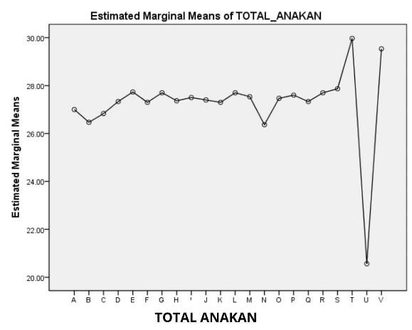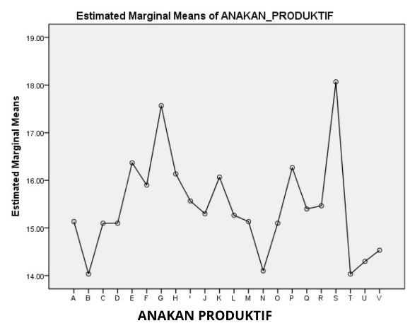
Image 3. Data pattern of total tillers and produktif tillers in rice

Total Tillers and Productive Tillers
The results of the 5% DMRT test analysis (Table 4) show that the average value of total tillers and the best productive tillers within the progenies of Ciherang varieties x B11143D are line 124.3.2 with an average total tillers of 27,867 and productive tillers 18,067 stems per clump, followed by line 20.4.4 with a total tillers of 27,700 and productive tillers 17,567, and line 94.3.3 with a total tillers of 27,300 and productive tillers 16,067 stems per clump.
Image 3 shows that the average value of total tillers and productive tillers of rice progenies resulting from the best cross of Ciherang variety x B11143D has higher value than Ciherang as the restorer parent. This is thought to be because the desired character traits of the donor parent successfully entered into the progenies. Susilowati et al. (2014) showed that B11143D line is the best donor parent for the improvement of Ciherang variety. In the crossing of Ciherang x B11143D, the character of rice tillers of B11143D line was likely transferred to the progenies.
The B11143D strain is a new type of rice that has agronomic characters, one of which is the small total number of tillers but almost all of them are productive tillers. Total tillers will affect the number of productive tillers. According to Atman and Yardha (2008) the number of productive tillers is closely related to the maximum total tillers where the more the number of tillers produced per clump of rice, the more the number of productive tillers it produces. The more the number of productive tillers increases the value of rice productivity.

CONCLUSION
Based on the results of the study showed that in the cultivation of rice strains crossed varieties Ciherang x B11143D strains there is a real influence of rice strains on the vegetative characters of rice strains crossed varieties Ciherang x B11143D strains in Telagasari District Karawang.
Of all the characters observed, the progenies of Ciherang variety x B11143D that produced the best results compared to others were line 124.2.3 with plant height of 115.283 cm, flag leaf length of 50.383 cm, flag leaf area of 100.767 cm², flowering age of 62.633 hss, total tillers of 27.867 and productive tillers of 18.067 stems per clump; Lines 94.3.3 and 20.4.4 ranked as the second and third best progenies. The vegetative characters possessed by the three selected lines are expected to affect the productivity to be better than the comparing varieties.

ACKNOWLEDGMENTS
Thank you to Mrs. Ani Lestari, S.Si., M.Si. and Dr. Vera Octavia Subardja S.P., M.Si. for guiding me to complete this research. Thank you to the National Research and Innovation Agency or BRIN, especially Dr. Wening Enggarini, S.Si., M.Si. for providing opportunities, guidance, and support. This research was made possible as part of the collaboration between Singaperbangsa Karawang University and Research Center for Genetic Engineering, Research Organization for Life Sciences anda Environment, National Research and Innovation Agency based on Cooperation Agreement No. 4087/UN64/KS/2022 and No. 270/V/KS/12/2022.

BIBLIOGRAPHY

Abdullah, B., Tjokrowidjojo, S., Kustianto, B., dan Darajat, A.A. 2005. Pembentukan Padi Varietas Unggul Tipe Baru. Penelitian Pertanian 24:1-7.
Abdullah, B., Tjokrowidjojo, S., dan Sularjo, S. 2017. Perkembangan dan Prospek Perakitan Padi Tipe Baru di Indonesia.
Afrijon, A., Ilham, I., dan Jefri, P.N. 2021. Pengaruh Umur Pemotongan terhadap Panjang Daun, Lebar Daun dan Kandungan Protein Daun Padi (Oryza sativa L.) Varietas PB-42 pada Sistem Mina Padi. Jurnal Embrio, 13(2), 45-56.
Atman dan Yarda. 2006. Pengaruh Jumlah Bibit Terhadap Pertumbuhan dan Hasil Padi Sawah Varietas Batang Lembah. BPTP Sumatera Barat dan BPTP Jambi.
Daradjat, A.A., Widiarta, N., dan Hasanuddin, A. 1999. Breeding for Rice Tungro Virus Resistance in Indonesia. Rice Tungro Disease Management, 31-38.
Gomez, K.A. dan Gomez, A.A. 2010. Prosedur Statistik untuk Penelitian. Universitas Indonesia, Jakarta.
Hasmeda, M., Halimi, E.S., dan Guswari, R. Y. 2017. Evaluasi Pertumbuhan dan Seleksi Tanaman Padi Aksesi BC2F2 Toleran Cekaman Terendam Serta Persilangan Balik-nya dengan Tetua Lokal. Jurnal Lahan Suboptimal: Journal of Suboptimal Lands, 6(1) : 7-20.
Husna, A., Nandariyah, N., Yuniastuti, E., dan Sakya, A.T. 2022. Karakter Fisik Gabah Hasil Persilangan Backcross 2 Galur Harapan Padi Hitam/Jeliteng//Jeliteng. Prosiding Seminar Nasional Fakultas Pertanian UNS 6(6) : 1-9.
Karim, W. 2014. Keterkaitan Antara Karakter Panjang Daun Bendera dengan Preferensi Burung Pipit, Kualitas Biji, dan Daya Hasil pada Tanaman Padi (Oryza sativa L.). Makalah Seminar Umum Jurusan Budidaya Universitas Gadjah Mada, Yogyakarta.
Putih, R., Anwar, A., dan NAR, G.R. 2011. Variabilitas Genetik Karakter Umur, Hasil dan Komponen Hasil Beberapa Genotipe Padi Lokal (Oryza sativa L.) Sumatera Barat. Seminar Nasional: Reformasi Pertanian Terintegrasi Menuju Kedaulatan Pangan. Jakarta. Terjemahan Susilo H. Hal 155 dan 269.
Siregar, H. 1981. Budi Daya Tanaman Padi di Indonesia. P.T. Sastra Hudaya. Jakarta.
Suprihatno, B., Darajat, A.A., Satoto, Baehaki, Widiarta, N., Indrasari, S.D., Lesmana, O.S., dan Sembiring, H. 2007. Deskripsi Varietas Padi. Badan Penelitian dan Pengembangan Pertanian. Balai Besar Penelitian dan Pengembangan Padi. Sukamandi.
Susilowati, M., Basunanda, P., Enggarini, W., Ma’sumah, dan Trijatmiko, K.R. 2014. Survei Polimorfisme Tetua untuk Pengembangan Panel CSSL Padi (Oryza sativa L.) dan Identifikasi Tanaman F1. J AgroBio 10:85-92.
Tarwyati, D.N., Sodikin, I., Nuraeni, D., Ismaryati, E., Irnawati., Wahyuningsih, Ari., Mintoraras, Asti., Susanto, Toni Tri., Nugroho, dan Nurtamtomo, H. 2021. Sub Koordinator Kelompok Substansi Analisis Harga Pangan Produsen dan Sub Koordinator Kelompok Substansi Analisis Harga Pangan Konsumen. Produsen dan Sub Koordinator Kelompok Substansi Analisis Harga Pangan Konsumen Eds., p. 48.
Yulina, N., Ezward, C., dan Haitami, A. 2021. Karakter Tinggi Tanaman, Umur Panen, Jumlah Anakan dan Bobot Panen pada 14 Genotipe Padi Lokal. Jurnal Agrosains dan Teknologi, 6(1) : 15-24.

